**Walmart Store Analysis and Forecasting:**

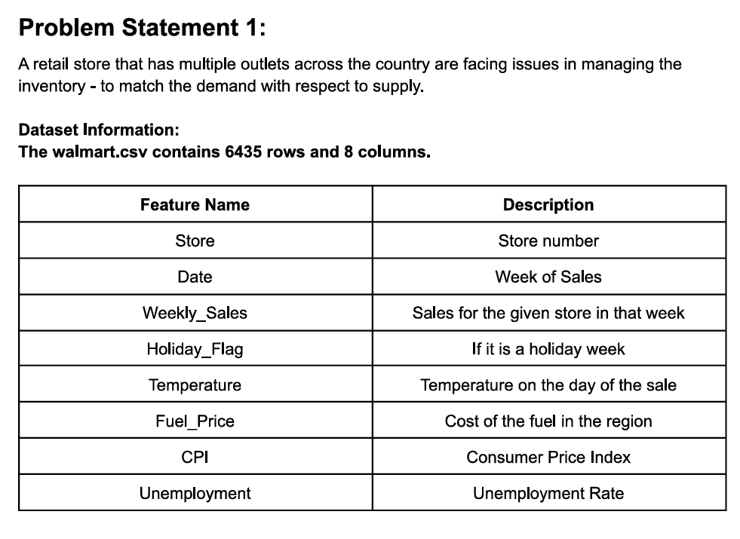

**Sales based on Holidays:**

* More sales occurred during Holidays

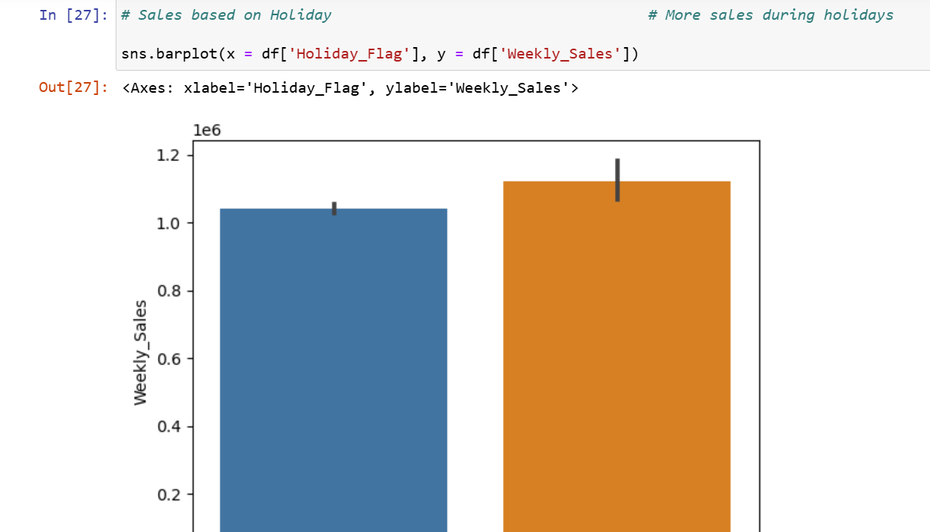

**Sales based on Unemployment rate:**

* Sales is high when Unemployment rate is 9

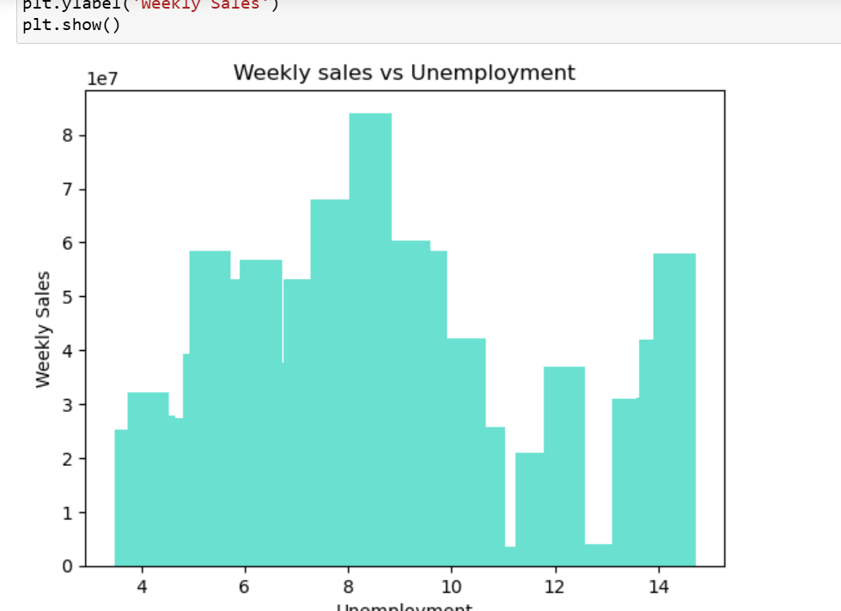

**Sales based on Temperature:**

* Low sales when temperature is lesser than 20

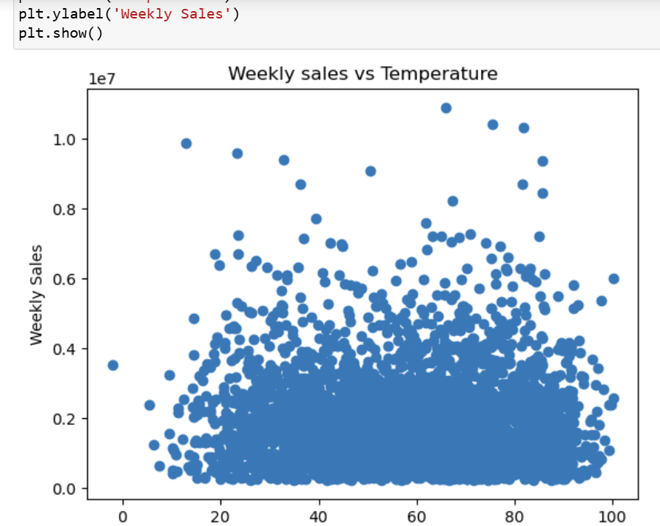

**Sales based on CPI:**

* Sales is minimum for CPI between 140 and 180

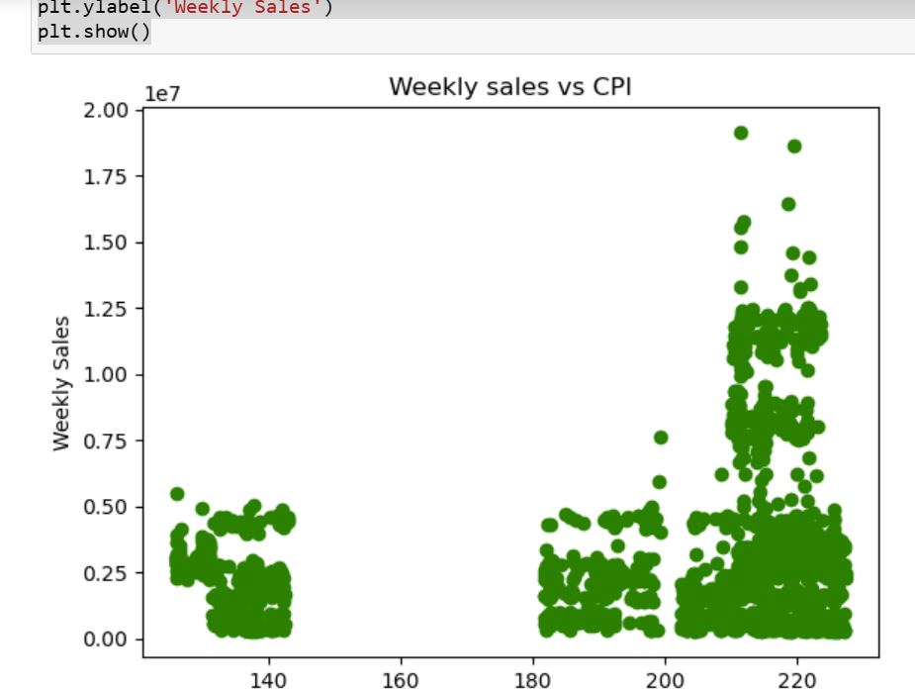

**Top and low performing stores:**

* Top performing stores: Stores 20 and 4
* Low performing stores: Stores 33 and 44

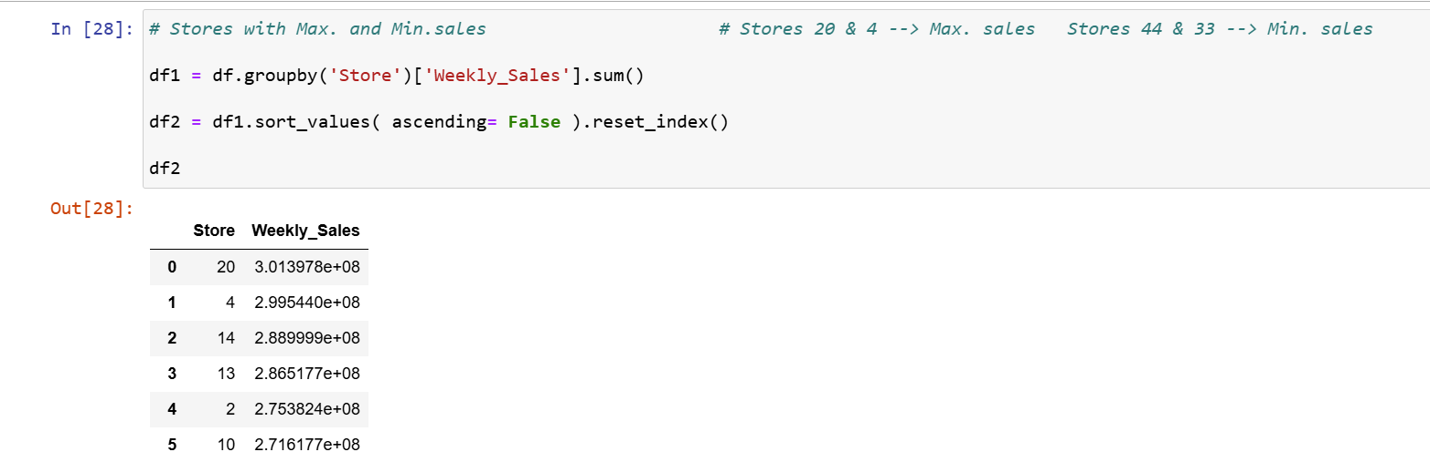

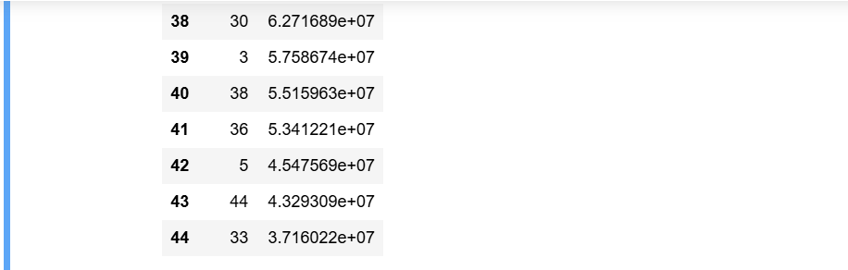

**Predictive Modelling:**

* Time series Forecasting

**Store 1 :**

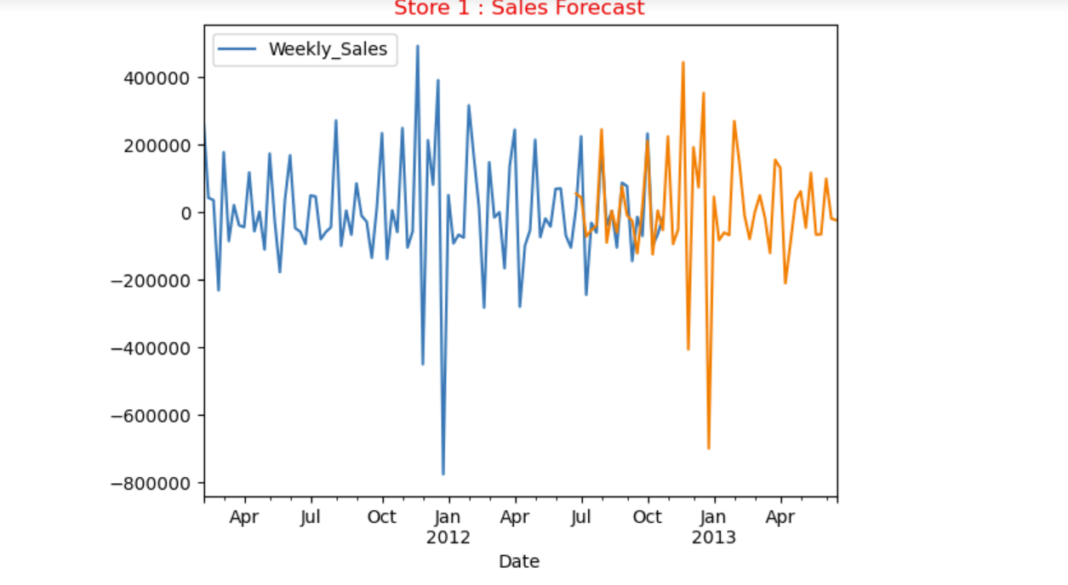

**Store 37 :**

